
Pre-AP Biology
Unit 6 – Meiosis and Genetics
Suggested Duration: 11 Days

Meiosis and Genetics
UNIT PLAN

Table of Contents
UNIT NARRATIVE 1
CONTENT STANDARDS 2
UNDERSTANDINGS AND QUESTIONS 2
ROADMAP 3
UNPACKED STANDARDS 13
VERTICAL ALIGNMENTS…………………………………………………………………………………………………………………………………………………………………………………………....15
VOCABULARY GLOSSARY 16

UNIT NARRATIVE
Students have completed learning on the process/steps of mitosis. At the beginning of this unit, students learn and create models of the process of meiosis. This is accomplished through a Meiosis Gizmo, an activity where they find similarities/differences between mitosis and meiosis, and finally a hands-on-minds-on activity where the “walk” through the steps of meiosis and use the resulting gametes to find genotypes and phenotypes (which introduces them to genetics). Students should learn that the reduction of chromosome number in meiosis allows for the zygote (sperm + egg) to have the same number of chromosomes as a normal somatic cell. Conceptual understanding of how meiosis and fertilization creates genetic diversity in this unit will be key in the next chapter when we discuss natural selection and gene pool diversity. Students then participate in two Gizmo activities that allow students to breed mice in order to determine their genotype and phenotypes, both through the perspective of one trait (monohybrid cross) and two traits (dihybrid cross). Students then take this knowledge and apply it to scenarios that don’t follow normal Mendelian inheritance (codominance, incomplete dominance, multiple alleles, and sex-linked). The unit ends with a plethora of inheritance practice problems that will allow students to show mastery before taking the unit exam.

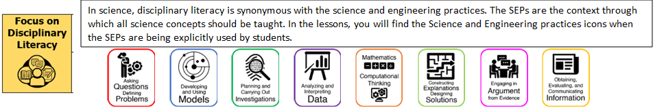

CONTENT STANDARDS
Below are the standards taught and assessed in this unit.
Learning Objectives (Students will be able to…)
B.8.A – analyze the significance of chromosome reduction, independent assortment, and crossing-over during meiosis in increasing diversity in populations of organisms that reproduce sexually
B.8.B – predict possible outcomes of various genetic combinations using monohybrid and dihybrid crosses, including non-Mendelian traits of incomplete dominance, codominance, sex-linked traits, and multiple alleles

UNDERSTANDINGS AND QUESTIONS
Important big ideas and processes for the unit.
Enduring Understandings
- Meiosis is a process that reduces the number of chromosomes from the normal diploid number to a haploid number which allows for the zygote to have the normal diploid number.
- Meiosis is a mechanism that allows for the introduction of variation into populations.
- Encoded in DNA is the heritable information responsible for the synthesis of RNA, which makes gene expression possible.
- Models can be used to illustrate and predict the inheritance of traits.
Key Questions
- What occurs during the process of meiosis?
- What type of cells are produced during meiosis?
- What is the law of independent assortment and why is it so important?
- How are mitosis and meiosis similar? Different?
- What is the difference between homologous chromosomes and chromatids?
- What is the difference between a dominant and recessive allele? Trait?
- What is the difference between genotype and phenotype?
- What is a punnett square and what is it used for?
- What is the difference between a monohybrid cross and a dihybrid cross?
- What is the difference between homozygous recessive, homozygous dominant, and heterozygous?
- How is incomplete dominance different from complete dominance?
- How is codominance different from complete dominance?
- How is inheritance from multiple alleles different from complete dominance?
- How is sex-linked inheritance different from complete dominance?

ROADMAP
Suggested daily guide for instruction in this unit.

Lesson #1: Meiosis Gizmo |  | Date:
Objective  SWBAT: Investigate how variation is increased due to the process of meiosis.  Standards  B.8.A – analyze the significance of chromosome reduction, independent assortment, and crossing-over during meiosis in increasing diversity in populations of organisms that reproduce sexually  Vocabulary  Prophase (I and II)  Metaphase (I and II)  Anaphase (I and II)  Telophase (I and II)  Homologous chromosomes  Diploid  Haploid  Gamete  Meiosis  Zygote  Dominant  Recessive  Science Practices  - Asking Questions  - Developing and Using Models  - Planning and Carrying Out Investigations  - Using Mathematics  - Constructing Explanations  - Engaging in Argument from Evidence  - Communicating Information | Instructional Notes  Lesson Overview  In the Meiosis Gizmo, students will observe the steps of meiosis, compare the process in male and female cells, and discover what can go wrong. They will use crossovers to produce diverse sets of gametes and create offspring with specific genotypes and phenotypes.  The Student Exploration sheet contains four activities:  - Activity A – Students learn the steps of meiosis in male cells and observe how meiosis is different from mitosis.  - Activity B – Students compare meiosis in female cells to meiosis in male cells.  - Activity C – Students observe how genetic diversity is created in gametes using crossovers and independent assortment of chromosomes.  - Activity D – Students experiment with crossovers in fruit fly sex cells to produce offspring with specific genotypes and phenotypes. |  | Lesson Look Fors  Look for teachers to:  - Allow students to productively struggle with the content, using accountable talk moves to facilitate the lesson.  - Asking probing questions throughout the presentation that pushes students’ thinking.  Look for students to:  - Engage in the online simulation and fill out the student document.  - Ask clarifying questions regarding what they are learning  - Write in complete sentences  Students Do and Know
   | - Interact with the simulation and answer questions regarding concepts learned.  - Investigate each step of meiosis and determine the resulting genotype and phenotype.  - Make conclusions based on models seen.
   | - Meiosis is the process by which gametes (sperm and egg) are made.  - Meiosis has 2 divisions which produces 4 daughter cells created from one mother cell.  - Each daughter cell is haploid; it contains half the number of chromosomes as the mother cell.  - Crossing over, independent assortment, and random fertilization increase genetic variability in the population

Lesson #2: Mitosis vs Meiosis |  | Date:
Objective  SWBAT: Create models to investigate the similarities/differences between mitosis and meiosis.  Standards  B.8.A – analyze the significance of chromosome reduction, independent assortment, and crossing-over during meiosis in increasing diversity in populations of organisms that reproduce sexually  Vocabulary  Prophase (I and II)  Metaphase (I and II)  Anaphase (I and II)  Telophase (I and II)  Homologous chromosomes  Diploid  Haploid  Gamete  Meiosis  Zygote  Dominant  Recessive  Science Practices  - Developing and Using Models  - Constructing Explanations  - Engaging in Argument from Evidence  - Communicating Information | Instructional Notes  Activity #1: Students will watch a short Mitosis vs Meiosis Video (Amoeba Sisters) while filling out their guided notes.  Activity #2: Students will then take a blank piece of paper and draw a model of each process, noting the differences between the two processes. Allow them to have some productive struggle here. We want them to use their notes, their peers, and their own knowledge to create the two models. You can have them do these models on large butcher paper or poster board, which would be awesome!  Activity #3: Students complete the Mitosis vs Meiosis Activity (card sort with questions).  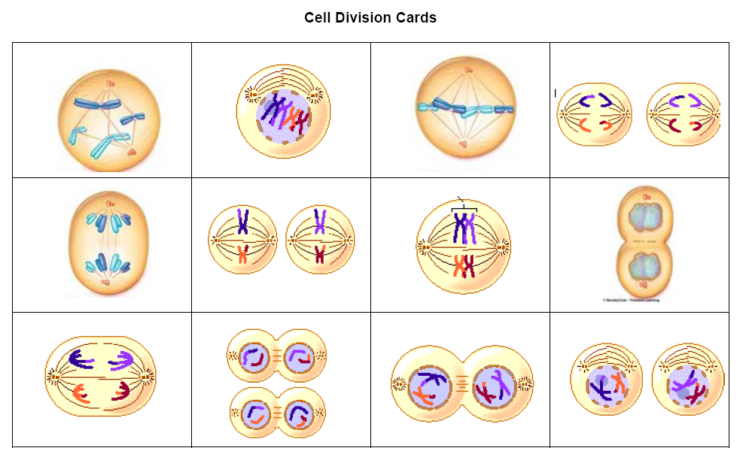 |  | Lesson Look Fors  Look for teachers to:  - Allow students to productively struggle with the content, using accountable talk moves to facilitate the lesson.  - Asking probing questions throughout the presentation that pushes students’ thinking.  Look for students to:  - Ask clarifying questions regarding what they are learning  - Write in complete sentences  Students Do and Know
  - Analyze models of mitosis and meiosis for similarities and differences.
  - Meiosis is the process by which gametes (sperm and egg) are made.
  - Meiosis has 2 divisions which produces 4 daughter cells created from one mother cell.
  - Each daughter cell is haploid; it contains half the number of chromosomes as the mother cell.
  - Crossing over, independent assortment, and random fertilization increase genetic variability in the population.
  - Mitosis is the process by which somatic cells are replicated.
  - Mitosis has only one division and produces two daughter cells.
  - Mitosis produces diploid daughter cells from a diploid mother cells (daughter cells have the same amount of chromosomes as the mother cell.)

Lesson #3: The Amazing Sperm Race |  | Date:
Objective  SWBAT: Determine the genotype and phenotype of a zygote based on the genetics of the sperm and egg.  Standards  B.8.A – analyze the significance of chromosome reduction, independent assortment, and crossing-over during meiosis in increasing diversity in populations of organisms that reproduce sexually  Vocabulary  Prophase (I and II)  Metaphase (I and II)  Anaphase (I and II)  Telophase (I and II)  Homologous chromosomes  Diploid  Haploid  Gamete  Meiosis  Zygote  Dominant  Recessive  Science Practices  - Asking Questions  - Developing and Using Models  - Planning and Carrying Out Investigations  - Using Mathematics  - Constructing Explanations  - Engaging in Argument from Evidence  - Communicating Information | Instructional Notes  ABOUT THIS LESSON  This activity involves an inexpensive, hands-on, and exciting way for students to experience how homologous chromosomes undergo meiosis to produce gametes. This activity culminates  in a “race” to determine a zygote’s genotypic and phenotypic characteristics. This is an essential lesson because it provides a deep, rich context for past heredity content in the middle grades and sets the foundation for all future learning in genetics.  OBJECTIVES  Students will:  - Simulate the process of meiosis using pool noodle chromosomes  - Determine the phenotype and genotype of a zygote  - Compare and contrast mitosis and meiosis  - Articulate the steps of Meiosis I and II  - Analyze the impact that meiosis has on genetic variability in a population  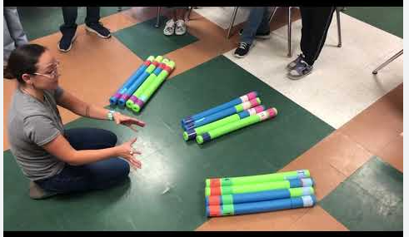 |  | Lesson Look Fors  Look for teachers to:  - Allow students to productively struggle with the content, using accountable talk moves to facilitate the lesson.  - Asking probing questions throughout the presentation that pushes students’ thinking.  Look for students to:  - Ask clarifying questions regarding what they are learning  - Write in complete sentences  Students Do and Know
  - Model the phases of meiosis with peers.
  - Determine genotypes and phenotypes based on which sperm fertilized a particular egg.
  - Meiosis is the process by which gametes (sperm and egg) are made.
  - Meiosis has 2 divisions which produces 4 daughter cells created from one mother cell.
  - Each daughter cell is haploid; it contains half the number of chromosomes as the mother cell.
  - Crossing over, independent assortment, and random fertilization increase genetic variability in the population.

Lesson #4: Mendelian Genetics (Monohybrid Crosses) |  | Date:
Objective  SWBAT: Determine genotypic and phenotypic ratios from a monohybrid cross.  Standards  B.8.B – predict possible outcomes of various genetic combinations using monohybrid and dihybrid crosses, including non-Mendelian traits of incomplete dominance, codominance, sex-linked traits, and multiple alleles  Vocabulary  Monohybrid  Genotype  Phenotype  Homozygous dominant  Homozygous recessive  Heterozygous  Punnett square  Dominant  Recessive  Science Practices  - Asking Questions  - Developing and Using Models  - Planning and Carrying Out Investigations  - Using Mathematics  - Constructing Explanations  - Engaging in Argument from Evidence  - Communicating Information | Instructional Notes  Lesson Overview  In 1865, an Austrian monk named Gregor Mendel presented  a paper on pea plant inheritance to the Natural History  Society of Brünn. The paper was received politely but  generated little interest, and it was virtually ignored for 30  years. Years after Mendel’s death, several biologists  independently discovered similar patterns of inheritance, and  Mendel’s work was rediscovered. These patterns became  the basis for a new branch of biology: genetics.  The Mouse Genetics (One Trait) Gizmo™ allows students to  conduct breeding experiments similar to Mendel’s pea plant  experiments. Along the way they will discover how traits are  passed down from parents to offspring.  The Student Exploration sheet contains three activities:  - Activity A – Students breed mice and observe the phenotypes of the offspring.  - Activity B – Students observe how alleles are passed down from parent to offspring.  - Activity C – Students use Punnett squares to predict the percentages of black and white offspring of a particular parent pair.  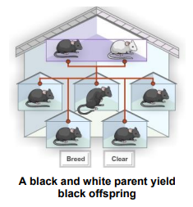 |  | Lesson Look Fors  Look for teachers to:  - Allow students to productively struggle with the content, using accountable talk moves to facilitate the lesson.  - Asking probing questions throughout the presentation that pushes students’ thinking.  Look for students to:  - Engage in the online simulation and fill out the student document.  - Ask clarifying questions regarding what they are learning  - Write in complete sentences  Students Do and Know
  - Interact with the simulation and answer questions regarding concepts learned.
  - Investigate each scenario and determine the resulting genotype and phenotype.
  - Make conclusions based on models seen.
  - When one allele of a gene overrules the other, the dominant allele is expressed and the recessive allele is masked.
  - Homozygous (AA, aa) means having two identical versions of a gene, while heterozygous (Aa) means having two different versions of a gene.
  - The Punnett square is a table in which all of the possible outcomes for a genetic cross between two individuals with known genotypes are given.
  - Genotype refers to an organism's genetic makeup, while phenotype refers to its observable traits.
  - A monohybrid cross is one involving only one trait.

Lesson #5: Mendelian Genetics (Di-hybrid Crosses) |  | Date:
Objective  SWBAT: Determine genotypic and phenotypic ratios from a dihybrid cross.  Standards  B.8.B – predict possible outcomes of various genetic combinations using monohybrid and dihybrid crosses, including non-Mendelian traits of incomplete dominance, codominance, sex-linked traits, and multiple alleles  Vocabulary  Monohybrid  Dihybrid  Genotype  Phenotype  Homozygous dominant  Homozygous recessive  Heterozygous  Punnett square  Dominant  Recessive  Science Practices  - Asking Questions  - Developing and Using Models  - Planning and Carrying Out Investigations  - Using Mathematics  - Constructing Explanations  - Engaging in Argument from Evidence  - Communicating Information | Instructional Notes  Activity #1: Mouse Genetics Gizmo Two Traits  In the Mouse Genetics (One Trait) Gizmo, students learned  to use Punnett squares to model the inheritance of a single  trait, fur color. The Mouse Genetics (Two Traits) Gizmo  shows the inheritance of fur color and eye color.  The Student Exploration sheet contains three activities:  - Activity A – Students breed mice and find patterns in the offspring phenotypes.  - Activity C – Students use a 4×4 Punnett square to model the inheritance of two traits.  Activity #2: Students will practice solving genetics problems involving both monohybrid and dihybrid crosses.  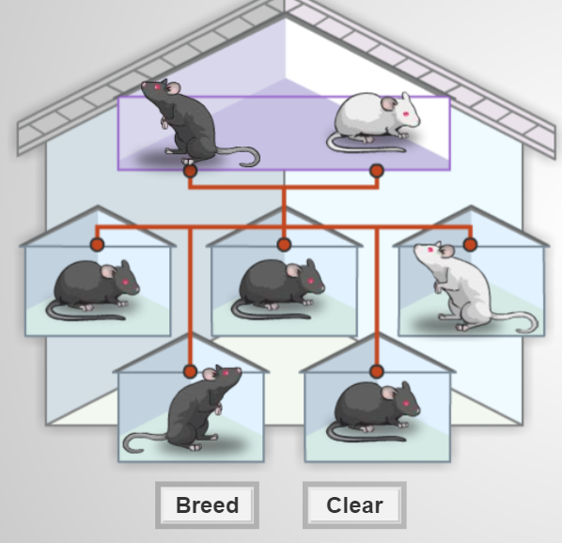 |  | Lesson Look Fors  Look for teachers to:  - Allow students to productively struggle with the content, using accountable talk moves to facilitate the lesson.  - Asking probing questions throughout the presentation that pushes students’ thinking.  Look for students to:  - Engage in the online simulation and fill out the student document.  - Ask clarifying questions regarding what they are learning  - Write in complete sentences  Students Do and Know
  - Interact with the simulation and answer questions regarding concepts learned.
  - Investigate each scenario and determine the resulting genotype and phenotype.
  - Make conclusions based on models seen.
  - When one allele of a gene overrules the other, the dominant allele is expressed and the recessive allele is masked.
  - Homozygous (AA, aa) means having two identical versions of a gene, while heterozygous (Aa) means having two different versions of a gene.
  - The Punnett square is a table in which all of the possible outcomes for a genetic cross between two individuals with known genotypes are given.
  - Genotype refers to an organism's genetic makeup, while phenotype refers to its observable traits.
  - A dihybrid cross is one involving two traits.
Lesson #6: Non-Mendelian Genetics |  | Date:
Objective  SWBAT: Determine genotypic and phenotypic ratios from crosses that do not follow normal Mendelian genetics.  Standards  B.8.B – predict possible outcomes of various genetic combinations using monohybrid and dihybrid crosses, including non-Mendelian traits of incomplete dominance, codominance, sex-linked traits, and multiple alleles  Vocabulary  Monohybrid  Dihybrid  Codominance  Incomplete dominance  Multiple alleles  Genotype  Phenotype  Homozygous dominant  Homozygous recessive  Heterozygous  Punnett square  Dominant  Recessive  Science Practices  - Developing and Using Models  - Using Mathematics  - Constructing Explanations  - Engaging in Argument from Evidence  - Communicating Information | Instructional Notes  Activity #1: Teachers will facilitate a PowerPoint over non-Mendelian genetics. Students will fill out a thought catcher as you go through slides. The thought catcher has practice problems for students to solve as you go through the PPT. This activity will cover the following concepts:  - Codominance  - Incomplete dominance  - Multiple alleles  Activity 2: Students will get into groups of 2 and complete the set of practice problems involving non-Mendelian genetics.  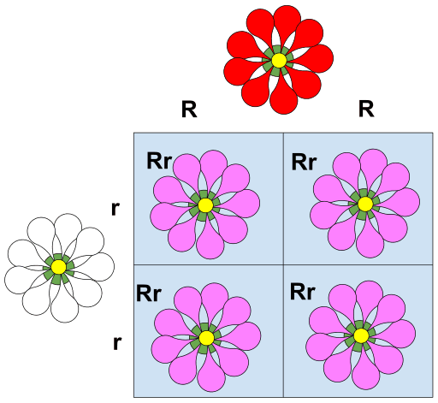 |  | Lesson Look Fors  Look for teachers to:  - Allow students to productively struggle with the content, using accountable talk moves to facilitate the lesson.  - Asking probing questions throughout the presentation that pushes students’ thinking.  Look for students to:  - Engage in the guided notes and solve genetics problems.  - Ask clarifying questions regarding what they are learning  - Write in complete sentences  Students Do and Know
  - Interact with the PowerPoint presentation and answer questions regarding concepts learned.
  - Investigate each scenario and determine the resulting genotypic and phenotypic ratios.
  - Make conclusions based on models seen.
  - Incomplete dominance is a genetic pattern where two alleles blend to create a new phenotype, or a mix of the two, instead of one allele being completely dominant over the other.
  - Codominance is a type of inheritance where two different versions (alleles) of a gene are expressed equally, resulting in an individual displaying both traits.
  - Multiple alleles occur when there are more than two versions of a gene, or alleles, within a population.
Lesson #7: Sex-linked Inheritance and Genetics Problem Practice |  | Date:
Objective  SWBAT: Determine genotypic and phenotypic ratios from crosses involving genes on the X chromosome.  Standards  B.8.B – predict possible outcomes of various genetic combinations using monohybrid and dihybrid crosses, including non-Mendelian traits of incomplete dominance, codominance, sex-linked traits, and multiple alleles  Vocabulary  Monohybrid  Dihybrid  Codominance  Incomplete dominance  Multiple alleles  Sex-linked inheritance  Genotype  Phenotype  Homozygous dominant  Homozygous recessive  Heterozygous  Punnett square  Dominant  Recessive  Science Practices  - Developing and Using Models  - Using Mathematics  - Constructing Explanations  - Engaging in Argument from Evidence  - Communicating Information | Instructional Notes  Teachers will facilitate a PowerPoint over another non-Mendelian inheritance example called sex-linked inheritance. Students will fill out a thought catcher as you go through slides. The thought catcher has practice problems for students to solve as you go through the PPT.  Activity 2: It is vital that students get multiple at-bats at solving genetics problems. Students will get into groups of 2 and complete the set of practice problems involving non-Mendelian genetics. This activity will include genetics problems from both Mendelian AND non-Mendelian inheritance.  - Monohybrid crosses  - Dihybrid crosses  - Complete dominance  - Incomplete dominance  - Sex-linked inheritance  - Codominance  - Multiple alleles |  | Lesson Look Fors  Look for teachers to:  - Allow students to productively struggle with the content, using accountable talk moves to facilitate the lesson.  - Asking probing questions throughout the presentation that pushes students’ thinking.  Look for students to:  - Engage in the guided notes and solve genetics problems.  - Ask clarifying questions regarding what they are learning  - Write in complete sentences  Students Do and Know
  - Interact with the PowerPoint presentation and answer questions regarding concepts learned.
  - Investigate each scenario and determine the resulting genotypic and phenotypic ratios.
  - Make conclusions based on models seen.
  - Incomplete dominance is a genetic pattern where two alleles blend to create a new phenotype, or a mix of the two, instead of one allele being completely dominant over the other.
  - Codominance is a type of inheritance where two different versions (alleles) of a gene are expressed equally, resulting in an individual displaying both traits.
  - Multiple alleles occur when there are more than two versions of a gene, or alleles, within a population.
  - Sex-linked inheritance involves genes (alleles) that are located on the sex chromosomes.

Lesson #8: Pedigrees |  | Date:
Objective  SWBAT: Create a model (pedigree) that shows the genetics of three generations.  Standards  B.8.B – predict possible outcomes of various genetic combinations using monohybrid and dihybrid crosses, including non-Mendelian traits of incomplete dominance, codominance, sex-linked traits, and multiple alleles  Vocabulary  Monohybrid  Dihybrid  Codominance  Incomplete dominance  Multiple alleles  Sex-linked inheritance  Pedigree  Genotype  Phenotype  Homozygous dominant  Homozygous recessive  Heterozygous  Punnett square  Dominant  Recessive  Science Practices  - Developing and Using Models  - Using Mathematics  - Constructing Explanations  - Engaging in Argument from Evidence  - Communicating Information | Instructional Notes  Activity #1: Students will watch a short Pedigrees video (Amoeba Sisters) while filling out their guided notes. The video is set up so that you can stop the video and have students attempt to solve the problem before it is solved in the video.  Activity 2: Students will get into groups of 2 and complete the set of practice problems involving Pedigrees.  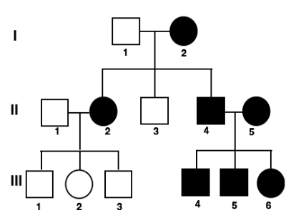 |  | Lesson Look Fors  Look for teachers to:  - Allow students to productively struggle with the content, using accountable talk moves to facilitate the lesson.  - Asking probing questions throughout the presentation that pushes students’ thinking.  Look for students to:  - Engage in the guided notes and solve genetics problems.  - Ask clarifying questions regarding what they are learning  - Write in complete sentences  Students Do and Know
  - Interact with the video presentation and answer questions regarding concepts learned.
  - Investigate each scenario and determine the resulting genotypic and phenotypic ratios.
  - Make conclusions based on models seen.
  - A pedigree in biology is a diagram that shows the inheritance of a trait or disease through a family's generations.
  - Incomplete dominance is a genetic pattern where two alleles blend to create a new phenotype, or a mix of the two, instead of one allele being completely dominant over the other.
  - Codominance is a type of inheritance where two different versions (alleles) of a gene are expressed equally, resulting in an individual displaying both traits.
  - Multiple alleles occur when there are more than two versions of a gene, or alleles, within a population.
  - Sex-linked inheritance involves genes (alleles) that are located on the sex chromosomes.

Day 9 | Review Day
Day 10 | Administer Unit Exam 6

UNPACKED STANDARDS
Focus standards for this unit.

Standards Clarification
Standards | Notes/Explanations/Examples
B.8.B – predict possible outcomes of various genetic combinations using monohybrid and dihybrid crosses, including non-Mendelian traits of incomplete dominance, codominance, sex-linked traits, and multiple alleles | Instructional Implications  Mendel’s principles of heredity (law of dominance, law of segregation, and law of independent assortment) form the basis of modern genetics and allow us to predict what is possible when two organisms create offspring. Predicting the possible outcomes of various genetic combinations lays the foundation for further study in selective breeding, evolution, and ecosystem stability. In some cases, there is not a clearly dominant allele, and many genes have multiple alleles. Students may struggle with this abstract concept because the cause/effect process of genetic combinations cannot be observed directly in the classroom. However, the effects of genetic combinations are observable.  When you teach this concept, remember to:  - Provide opportunities for students to predict phenotypic and genotypic ratios and percents from monohybrid and dihybrid crosses.  - Provide opportunities for students to evaluate and present written explanations about possible parents when provided offspring.  - Explore and model varied examples of non-Mendelian genetics using relevant, real-world examples (e.g., blood type).  - Help students see how they can create a cross when specific genotype letters are not provided for the traits.  Learning from Mistakes  - Not properly constructing Punnett squares for monohybrid and dihybrid crosses  - Miscalculating percentages and ratios for traits from a Punnett square  - Not recognizing the genotype that generated physical traits when presented with the phenotype of offspring
Specificity
Standard Breakdown:
- Predict possible outcomes of various genetic combinations using monohybrid crosses, including non-Mendelian traits of:
  - incomplete dominance
  - codominance
  - sex-linked traits
  - multiple alleles
- Predict possible outcomes of various genetic combinations using dihybrid crosses

Major concepts in this standard include:
- Genetics
- Mendel’s principles
- Punnett squares
- Non-Mendelian traits

B.8.A – analyze the significance of chromosome reduction, independent assortment, and crossing-over during meiosis in increasing diversity in populations of organisms that reproduce sexually | Instructional Implications  Meiosis creates cells that are different from one another and only contain one set of chromosomes. Recognizing the significance of meiosis to sexual reproduction lays the foundation for inheritance, genetics, and evolution. When you teach this concept, remember to:  - Demonstrate that meiosis occurs at the cellular level but causes genetic variation in the organism, leading to increased diversity of populations.  - Create opportunities for students to use models to associate cross-over with genetic variation and analyze its significance.  - Allow students to create models to use and explain their understanding of meiosis and gamete production.  - Create opportunities to observe, compare, and model meiosis I and meiosis II.  Students may make the following mistakes:  - Confusing genetic diagrams associated with meiosis and the stages of meiosis  - Not associating cross-over with creating genetic variation  - Confusing mitosis and meiosis
Specificity
Supports: This standard directly supports B.8(B) by illustrating the specific process (meiosis) that creates the genetic variation expressed in genes.

VERTCAL STANDARDS
This section details the progression of key student expectations/standards** in the courses before and after this course. This will help you understand what prior knowledge skills to build upon and guide you in knowing what skills you are preparing your students for in the subsequent course.

Biology Standard | Connections
B.8.A – analyze the significance of chromosome reduction, independent assortment, and crossing-over during meiosis in increasing diversity in populations of organisms that reproduce sexually | 7th Grade: S.7.13.C – compare the results of asexual and sexual reproduction of plants and animals in relation to the diversity of offspring and the changes in the population over time; and
B.8.B – predict possible outcomes of various genetic combinations using monohybrid and dihybrid crosses, including non-Mendelian traits of incomplete dominance, codominance, sex-linked traits, and multiple alleles | 1st Grade: S.1.13.C compare ways that young animals resemble their parents.  4th Grade: S.4.13.B differentiate between inherited and acquired physical traits of organisms.  8th Grade: S.8.13.B describe the function of genes within chromosomes in determining inherited traits of offspring; and  Biology: BIO.7.A identify components of DNA, explain how the nucleotide sequence specifies some traits of an organism, and examine scientific explanations for the origin of DNA;

VOCABULARY GLOSSARY
Domain-specific words and definitions for this unit.
Key Content Vocabulary
Allele – term coined to describe a specific copy of a gene.

Crossing over – During meiosis, when homologous chromosomes are paired together, there are points along the chromosomes that contact the other pair. This point of contact is deemed the chiasmata and can allow the exchange of genetic information between chromosomes. This further increases genetic variation.

Daughter cell – Daughter cells are cells that result from the division of a single parent cell.

Dihybrid cross – A dihybrid cross describes a mating experiment between two organisms that are identically hybrid for two traits.

Diploid – (of a cell or nucleus) containing two complete sets of chromosomes, one from each parent.

Fertilization – the action or process of fertilizing an egg, female animal, or plant, involving the fusion of male and female gametes to form a zygote.

Gamete – Gametes are an organism's reproductive cells. They are also referred to as sex cells. Female gametes are called ova or egg cells, and male gametes are called sperm. Gametes are haploid cells, and each cell carries only one copy of each chromosome. ... These cells develop into sperm or ova.

Gene – (in informal use) a unit of heredity which is transferred from a parent to offspring and is held to determine some characteristic of the offspring.

Genetics – Genetics is the study of heredity in general and of genes in particular. Genetics forms one of the central pillars of biology and overlaps with many other areas, such as agriculture, medicine, and biotechnology.

Genotype – the genetic constitution of an individual organism.

Haploid – (of a cell or nucleus) having a single set of unpaired chromosomes.

Homologous chromosomes – A homologous chromosome pertains to one of a pair of chromosomes with the same gene sequence, loci, chromosomal length, and centromere location.

Law of Independent assortment – Mendelian law stating that for every pair of unit factors, each of them would assort independently into the newly formed gametes

Law of segregation – ‘‘The two copies of each genetic factor segregate during the development of gametes, to ensure that each parent’s offspring attains one factor.’’ OR
‘‘During the development of the gamete, each gene is segregated in such a way that the gamete consists of just one allele for that gene.’

Meiosis – the process of cell division that results in the production of a haploid “daughter” cell with a haploid chromosomal number of a diploid “parent” (“original”) cell.

Meiosis I – The first of the two consecutive divisions of the nucleus of eukaryotic cell during meiosis, and composed of the following stages: prophase I, metaphase I, anaphase I, and telophase I

Meiosis II – The second of the two consecutive divisions of the nucleus of eukaryotic cell during meiosis, and composed of the following stages: prophase II, metaphase II, anaphase II, and telophase II

Mitosis – Mitosis is a process where a single cell divides into two identical daughter cells (cell division). During mitosis one cell? divides once to form two identical cells. The major purpose of mitosis is for growth and to replace worn out cells.

Monohybrid – A monohybrid cross is a cross between two organisms with different variations at one genetic locus of interest. The character(s) being studied in a monohybrid cross are governed by two or multiple variations for a single locus.

Mother cell – In cell division, a mother or parent cell is the cell that divides to give rise to two daughter cells. In mitosis, the two daughter cells contain the same genetic content as the mother cell.

Pedigree – A pedigree chart is a diagram that shows the occurrence and appearance of phenotypes of a particular gene or organism and its ancestors from one generation to the next, most commonly humans, show dogs, and racehorses.

Phenotype – used to describe a visible trait or characteristic

Sex-linked inheritance – Sex linked describes the sex-specific patterns of inheritance and presentation when a gene mutation is present on a sex chromosome rather than a non-sex chromosome. In humans, these are termed X-linked recessive, X-linked dominant and Y-linked.

Variation – the occurrence of an organism in more than one distinct color or form.

Zygote – a diploid cell resulting from the fusion of two haploid gametes; a fertilized ovum.

